**Transaction Isolation**

ACID: Transaction property.

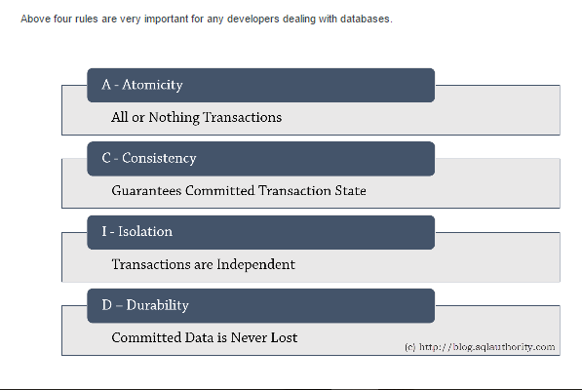

A. Transaction Isolation Levels

1. READ UNCOMMITTED  
   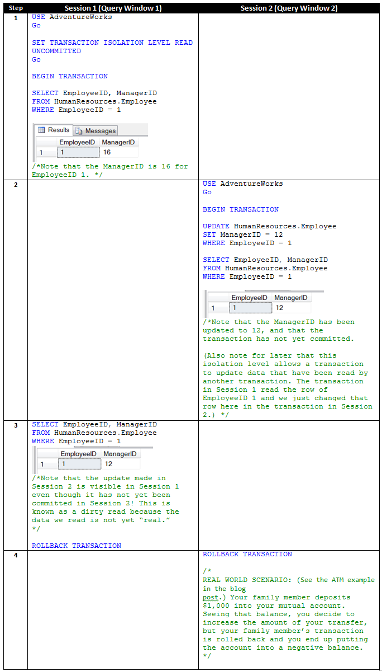
2. READ COMMITTED (Default)  
   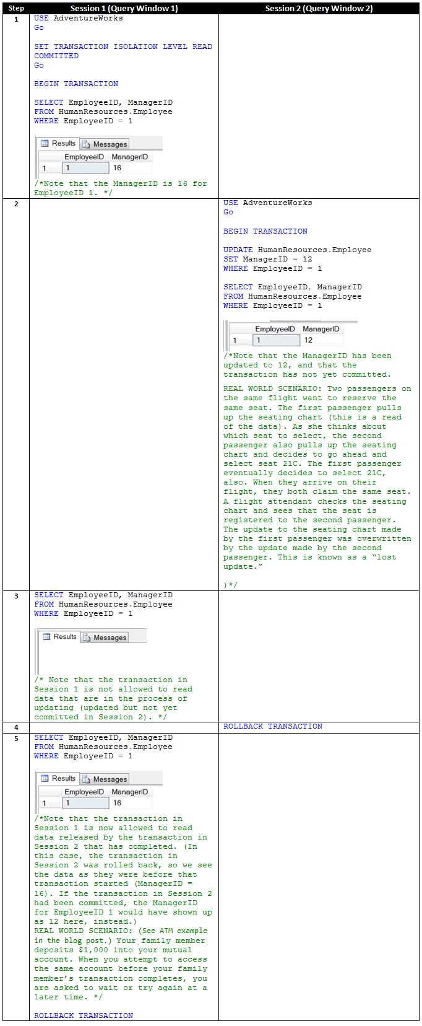
3. REPEATABLE READ  
   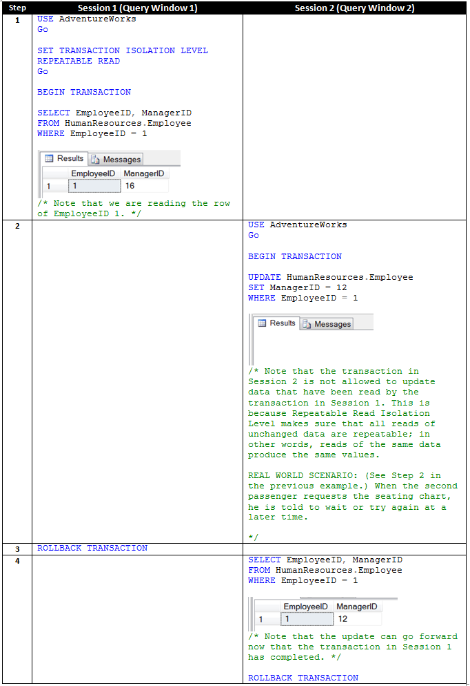
4. SERIALIZABLE  
   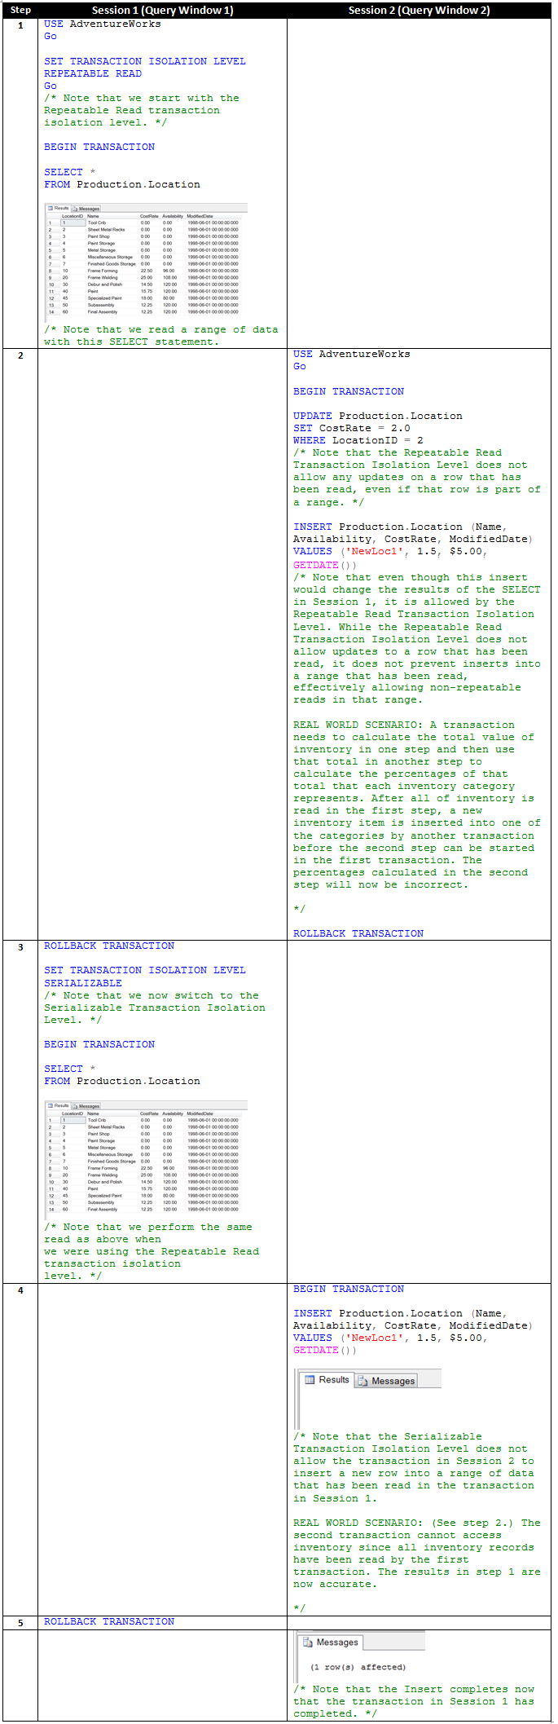
5. SNAPSHOT  
   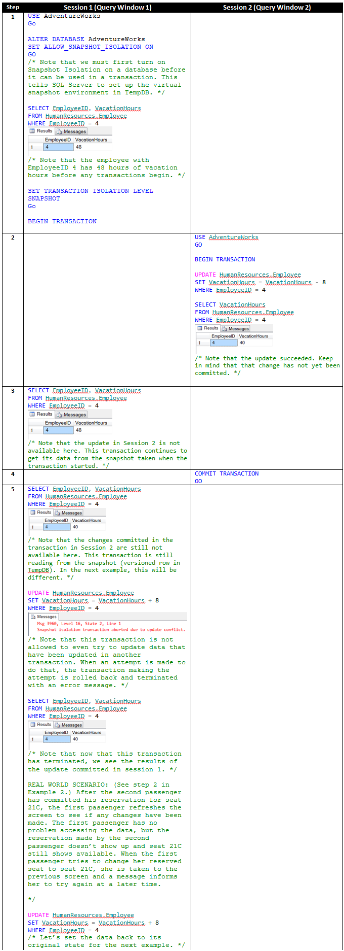

B. Statement Isolation Level

6. READ COMMITTED SNAPSHOT  
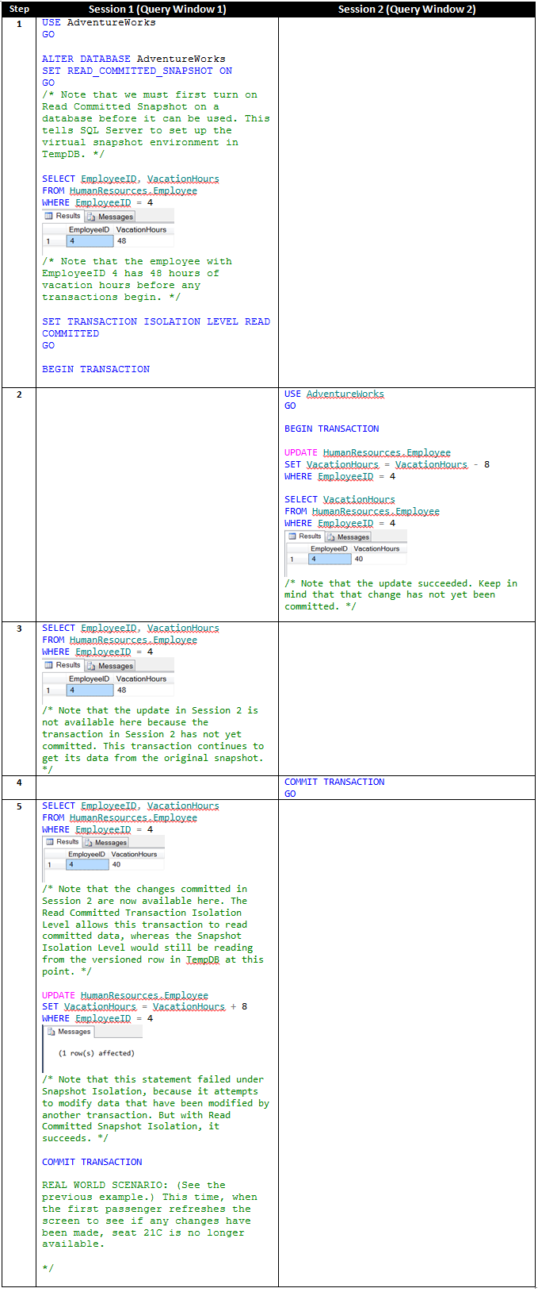

As you will see in the examples that follow, the higher the isolation level, the higher the level of protection (the more concurrency issues are prevented- Dirty read, Non repeatable read, Phantom read). Also, each isolation level includes the protections provided by the previous level so that each successively higher isolation level provides added protection in the form of more concurrency issues avoided. But, alas, nothing is free, and so the higher the isolation level, the less data availability there will be. Choosing the appropriate isolation level is a balancing act between highly safe concurrency and high data availability.